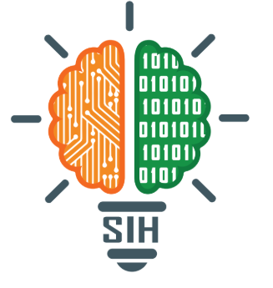
Team Member Details:
Ayush Das (23CSE572)
Abi Kumar Singh (23CSEDS027)
Adarsh Goyal (23CSEDS010)
Sarthak Shovan Panda (23CSEAIML056)
Jalumuru Sagar (23CSE646)
Pragnya Samal (23CSE578)
Student Innovation: Blood sample analysis using an image and pattern recognition model to accelerate the process of treatment of blood-related treatment.
PS Code: SIH25131
Problem Statement Title: BloodLens AI
Team Name: CodeX
Team Leader Name: Ayush Das
Theme Name: MedTech / BioTech / HealthTech

Idea/Approach Detail
Objective
To develop an cost effective AI-powered diagnostic tool to analyze the blood sample using image and pattern recognition that identifies potential diseases by analyzing the RBC , WBC , Platelets count and can also identify any possible anomaly in blood (i.e., parasites, contamination, and possible disease cells). We aim to bridge the critical time gap between testing and report generation, which often takes days to generate. By providing immediate care , our goal is to improve patient outcome and enables fast recovery.

Newness/Uniqueness of Innovation
Uses computer vision + pattern recognition to identify blood samples by identifying the RBC, WBC, and platelet count. The model can also detect any kind of unknown cell that can be a potential threat to the patient. Our core uniqueness is an algorithm that convert the 2D image to a 3D model to count the total number of Blood cells. Our model is optimized for 100x image. The model will be lightweight or cloud-based, as we are aiming the model for rural and remote areas, so it is easily accessible.

Potential Areas of Application in Industry/Market
- Healthcare diagnostics in rural and remote areas, and make the process faster
- Government health initiatives, we can add the AI model to the existing government health tech structure to make it more accessible and widespread in India
- Collaborating with NGOs, so that the process of diagnosing blood-related diseases can be faster
- Private Clinics it acts as a low cost aid .
- Veterinary aid This model can be retrained to analyze animal blood smear
Market Potential
- India has 65% of its population living in rural areas, which are challenged by access to quality diagnostics.
- The global health industry AI market is predicted to surpass USD 200 billion by 2030.
- Low-priced portable diagnostic kits can be aimed at primary health centers, schools, and camps to achieve widespread adoption.
- Low Barrier to Entry: The only hardware needed is an inexpensive micro-lens.

Technology

Frontend
- HTML: It is used to structure and display content on a web page.
- CSS: It is used to design and style the appearance of a website.
- JS: It is used to make a webpage dynamic and interactive.
- Flask: It is a Python framework used to make lightweight and flexible web applications in Python.
AI/ML
- YOLOv8: You Only Look Once version-8 is the latest version of the YOLO model hierarchy used for real-time object detection models released by Ultralytics
- TensorFlow: TensorFlow is the open-source model launched by google to train and deploy AI models
- Computer Vision: OpenCV, CNN-based models
- Data visualization : chart.js is used to visualize the comparing graph
Methodology
Data Foundation:
- Collected a comprehensive dataset from https://github.com/Shenggan/BCCD_Dataset.
- Prepared the image for training by cleaning them(Noise removal) and identifying key areas(Segmentation).
Image Input and Preprocessing:
- Image Addition: The System requires the user to upload the microscopic image of there blood smear.
- Image Standardization: The uploaded image undergoes automated preprocessing. This ensures the quality for the AI model.
AI-Based Cell Detection and Counting:
- Object Detection Model: The core of the prototype is to scan the preprocessed image to identify and clarify three distinct cell types: Red Blood Cells (RBCs), White Blood Cells (WBCs), and Platelets.
- Cell Counting: Once the cells are identified, the system simply counts them and shows how many of each type are present in the image.
Finding the Concentration of Cells in the Sample:
- 2D to 3D Conversion: In this stage the model converts 2D cell count from the image to an approximate 3D concentration(Cells Per Microliter).
Result Reporting and Visualization:
- Numerical Output: The model presents the final calculated values for RBC, WBC and Platelets concentrations to the user.
- Comparative Graph: The graph shows the patient’s cell counts side by side with the normal healthy ranges, making it easy to quickly spot if any cell type is too high or too low.
Microscope Used
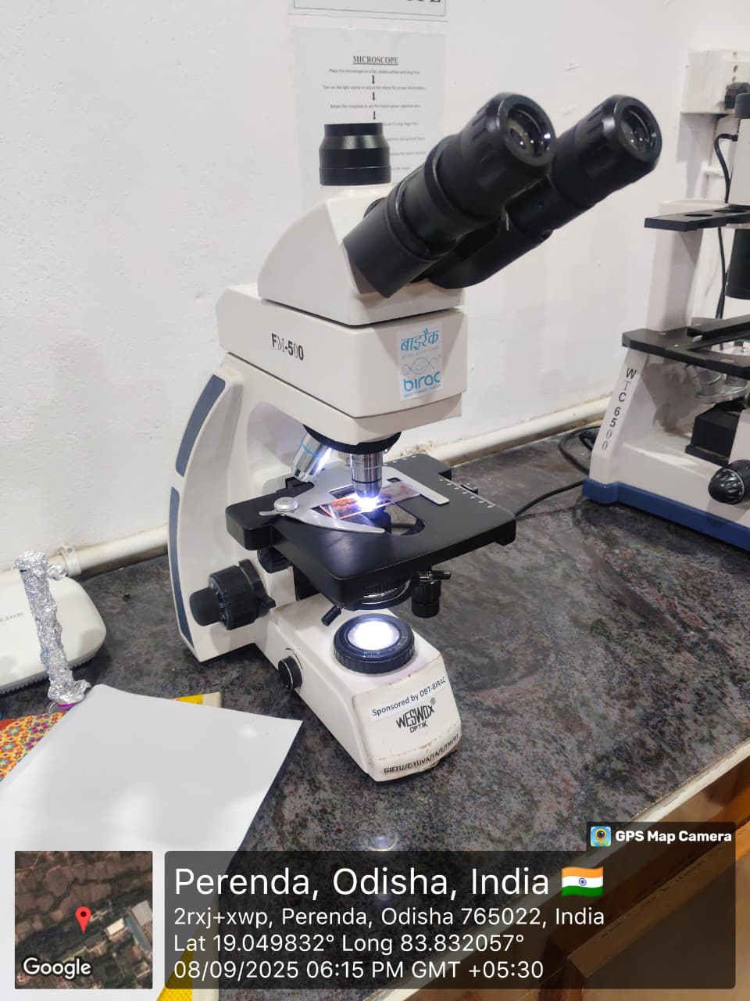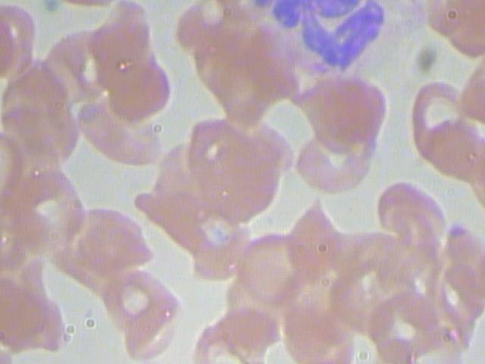

Future Scope

- Diseases Detection: The model will further train to detect the different type of diseases ( like: malaria , Anemia, leukemia ).
- Types of WBC: Enhance the model to detect different type of WBC cell(Neutrophils, Lymphocytes, Monocytes, etc.), providing us the more information about the Infection
- Mobile Application : Develop a Android and IOS application and integrate it to the model and use as a offine application with low Hardware Requirements
- Private organizations can be approached for their better tech and fund the model to make it more accurate to detect multiple diseases
- Report generation : It will generate the report that will tell the no. of blood count, possible infection and generate the report in the required language
- Quality check: it will first check the quality of image given as it is blurry , not in focus , or not in monolayer the tell to recapture the image and load it.

Solution
- Capture Image: The user will upload the microscopic image of a patient's blood smear.AI
- Analysis: The model will analyze the image and count the Red Blood Cells(RBCs), White Blood Cells(WBCs) and Platelets.
- Actionable Results: The model will estimate the number of cells (in cells/µL) and will show a graph comparing the patient’s results with normal healthy ranges.
- Integrated platform: An Ai model will be used to analyze the blood cell and give the count and any other things

Use cases
- Helping Rural Health Workers: Quick cell counts at PHCs without labs, so patients get faster treatment.
- Emergency & Disaster Response:Instant cell counts to guide rapid care decision and treatment decisions.
- Blood Bank Quality Checks :Fast, early screening of donated blood units before detailed lab testing.

Validation & Legitimacy

Making BloodLens AI accurate and dependable is our priority. As healthcare interventions directly affect patient results, our methodology is apt to examine the system carefully and ethically.

1. Comparison with Standard Pathology Reports

All AI-generated results (RBC, WBC, and Platelet counts) will be matched with verified pathology laboratory reports on corresponding samples.

Error margin analysis will also be performed to determine how closely the AI predictions are to the ground truth. An accuracy of ±5–10% of the pathology guidelines is desirable.

2. Confidence-Based Results

The system provides a confidence score with each prediction it makes.
If the level of confidence falls beneath some defined limit, then automatically the software generates a "Recheck Recommended" message.
This guarantees that inconclusive results are never regarded as certain
3. Transparency & Explainability
The deep learning model also incorporates explainability components, including heatmaps and attention maps, to reveal the areas of the smear image that truly impact the prediction.
This ensures the model is not perceived as merely a "black box," thereby enhancing the interpretability of the results for healthcare practitioners.

4. Doctor-in-Loop Design
BloodLens AI has been developed as a decision aid, rather than to replace registered diagnostic procedures.
All results will carry a disclaimer: "This is a preliminary report. Please confirm with a certified pathology test before definitive diagnosis."

5. Validation Roadmap
Dataset Validation– Preliminary testing with publicly known medical datasets (BCCD, Kaggle, WHO references).

Lab Comparisons – Comparing Benchmark Results of AI with Actual Pathology Reports from partner labs and pathologists.

Pilot Testing – Conducted in academic research facilities and primary health centers (PHCs) with proper expertise supervision.

Regulatory Awareness – For real-world deployment, compliance with ICMR/CDSCO guidelines will be pursued.

